**Creating Microservices for account and loan  
  
Account Microservice  
Code:**   
**AccountApplication.java :**  
package com.cognizant.account;

import org.springframework.boot.SpringApplication;

import org.springframework.boot.autoconfigure.SpringBootApplication;

*@SpringBootApplication*

public class AccountApplication {

public static void main(String[] args) {

SpringApplication.*run*(AccountApplication.class, args);

}

}  
**AccountController.java:**package com.cognizant.account.controller;

import org.springframework.web.bind.annotation.*;

import com.cognizant.account.model.Account;

*@RestController*

public class AccountController {

*@GetMapping*("/accounts/{number}")

public Account getAccount(*@PathVariable* String number) {

return new Account(number, "savings", 234343);

}

}

**Account.java :**package com.cognizant.account.model;

public class Account {

private String number;

private String type;

private double balance;

public Account() {

}

public Account(String number, String type, double balance) {

this.number = number;

this.type = type;

this.balance = balance;

}

public String getNumber() {

return number;

}

public void setNumber(String number) {

this.number = number;

}

public String getType() {

return type;

}

public void setType(String type) {

this.type = type;

}

public double getBalance() {

return balance;

}

public void setBalance(double balance) {

this.balance = balance;

}

}

**Application.properties:**spring.application.name=account

server.port=8088

**Output:**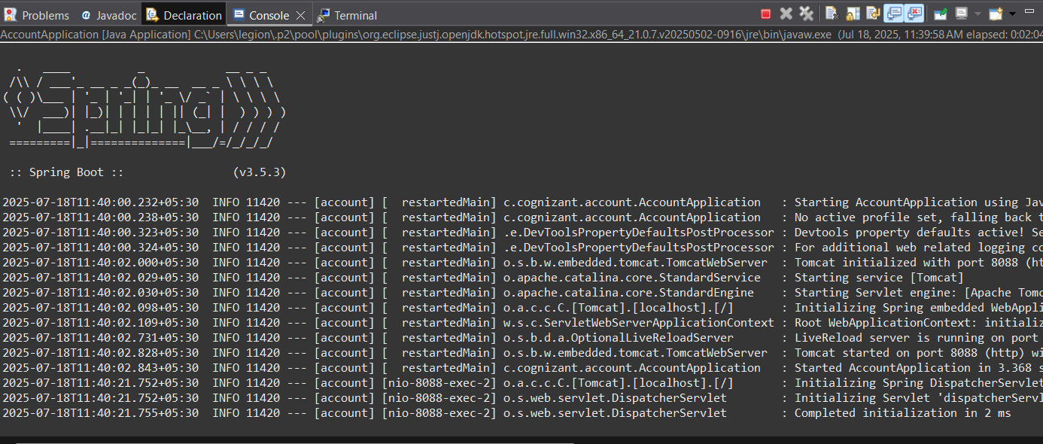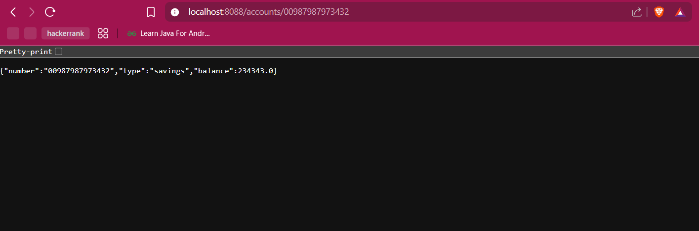

**Loan Microservice  
  
Code:  
LoanApplication.java:**package com.cognizant.loan;

import org.springframework.boot.SpringApplication;

import org.springframework.boot.autoconfigure.SpringBootApplication;

*@SpringBootApplication*

public class LoanApplication {

public static void main(String[] args) {

SpringApplication.*run*(LoanApplication.class, args);

}

}

**LoanController.java :**package com.cognizant.loan.controller;

import org.springframework.web.bind.annotation.*;

*@RestController*

public class LoanController {

*@GetMapping*("/loans/{number}")

public String getLoanDetails(*@PathVariable* String number) {

return "{ \"number\": \"" + number + "\", \"type\": \"car\", \"loan\": 400000, \"emi\": 3258, \"tenure\": 18 }";

}

}

**Application.properties:**spring.application.name=loan

server.port=8081

**Output:**